VERDE LENSES

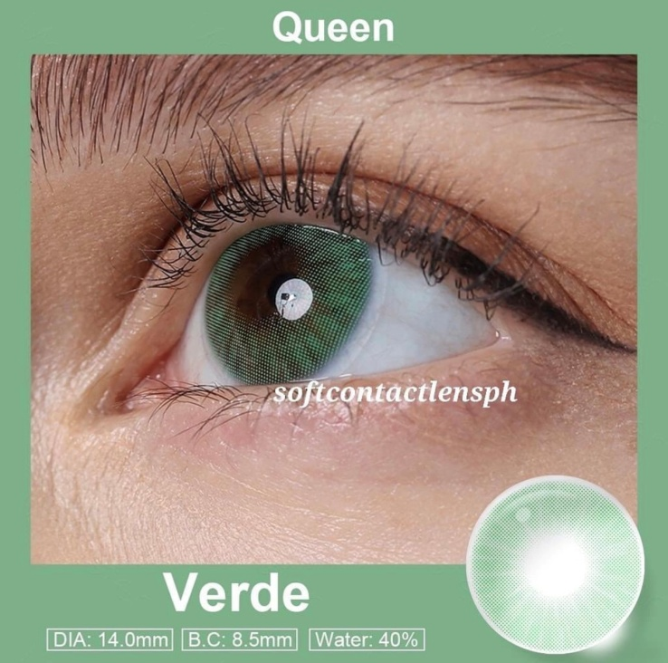

**DIA: 14.0mm**

**B.C: 8.5mm**

**WATER: 40%**

Verde contact lenses are a type of colored contact lenses that feature a green color. These lenses are designed to enhance or change the natural eye color, providing a unique and eye-catching appearance. Verde contact lenses come in various shades of green, ranging from subtle and natural-looking to more vibrant and intense colors. Like other colored contact lenses, Verde lenses are typically made from soft, breathable materials such as silicone hydro gel. These materials allow for comfortable wear and ensure proper oxygen flow to the eyes. It is important to note that contact lenses, including Verde contact lenses, should be prescribed and fitted by a qualified eye care professional. They will assess your eye health, provide a proper fitting, and guide you on the safe and appropriate use of these lenses based on your individual needs and eye condition. Proper care and maintenance of Verde contact lenses are essential to ensure their longevity and your eye health. Follow the cleaning and storage instructions provided by the manufacturer or your eye care professional. Additionally, adhere to the recommended wearing schedule and replace the lenses as directed to avoid any potential complications. If you are interested in trying Verde contact lenses, it is recommended to consult with an eye care professional that can provide personalized advice and guidance based on your specific requirements.